Chapter 9 Problems

1, 2, 3 = straightforward, intermediate, challenging

Section 9.1 Linear Momentum and its Conservation

1. A 3.00-kg particle has a velocity of . (a) Find its x and y components of momentum. (b) Find the magnitude and direction of its momentum.

2. A 0.100-kg ball is thrown straight up into the air with an initial speed of 15.0 m/s. Find the momentum of the ball (a) at its maximum height and (b) halfway up to its maximum height.

3. How fast can you set the Earth moving? In particular, when you jump straight up as high as you can, what is the order of magnitude of the maximum recoil speed that you give to the Earth? Model the Earth as a perfectly solid object. In your solution, state the physical quantities you take as data, and the values you measure or estimate for them.

4. Two blocks of masses M and 3M are placed on a horizontal, frictionless surface. A light spring is attached to one of them, and the blocks are pushed together with the spring between them (Fig. P9.4). A cord initially holding the blocks together is burned; after this, the block of mass 3M moves to the right with a speed of 2.00 m/s. (a) What is the speed of the block of mass M? (b) Find the original elastic potential energy in the spring if M = 0.350 kg.

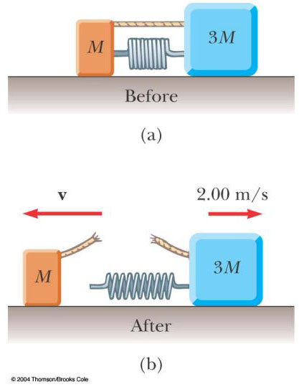

Figure P9.4

5. (a) A particle of mass m moves with momentum p. Show that the kinetic energy of the particle is K = p²/2m. (b) Express the magnitude of the particle’s momentum in terms of its kinetic energy and mass.

Section 9.2 Impulse and Momentum

6. A friend claims that, as long as he has his seatbelt on, he can hold on to a
12.0-kg child in a 60.0 mi/h head-on collision with a brick wall, in which the car passenger compartment comes to a stop in 0.050 0 s. Show that the violent force during the collision will tear the child from his arms. A child should always be in a toddler seat secured with a seat belt in the back seat of a car.

7. An estimated force-time curve for a baseball struck by a bat is shown in Figure P9.7. From this curve, determine (a) the impulse delivered to the ball, (b) the average force exerted on the ball, and (c) the peak force exerted on the ball.

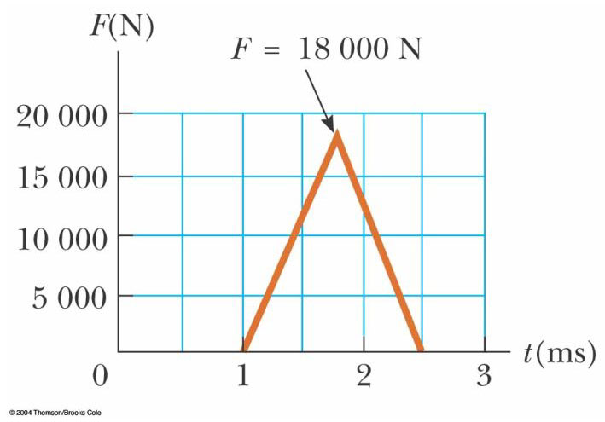

Figure P9.7

8. A ball of mass 0.150 kg is dropped from rest from a height of 1.25 m. It rebounds from the floor to reach a height of 0.960 m. What impulse was given to the ball by the floor?

9. A 3.00-kg steel ball strikes a wall with a speed of 10.0 m/s at an angle of 60.0° with the surface. It bounces off with the same speed and angle (Fig. P9.9). If the ball is in contact with the wall for 0.200 s, what is the average force exerted on the ball by the wall?

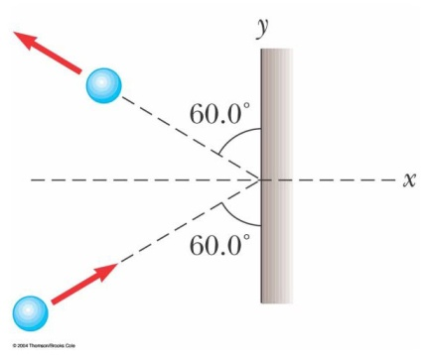

Figure P9.9

10. A tennis player receives a shot with the ball (0.060 0 kg) traveling horizontally at 50.0 m/s and returns the shot with the ball traveling horizontally at 40.0 m/s in the opposite direction. (a) What is the impulse delivered to the ball by the racquet? (b) What work does the racquet do on the ball?

11. In a slow-pitch softball game, a 0.200-kg softball crosses the plate at
15.0 m/s at an angle of 45.0° below the horizontal. The batter hits the ball toward center field, giving it a velocity of 40.0 m/s at 30.0° above the horizontal. (a) Determine the impulse delivered to the ball. (b) If the force on the ball increases linearly for
4.00 ms, holds constant for 20.0 ms, and then decreases to zero linearly in another 4.00 ms, what is the maximum force on the ball?

12. A professional diver performs a dive from a platform 10 m above the water surface. Estimate the order of magnitude of the average impact force she experiences in her collision with the water. State the quantities you take as data and their values.

13. A garden hose is held as shown in Figure P9.13. The hose is originally full of motionless water. What additional force is necessary to hold the nozzle stationary after the water flow is turned on, if the discharge rate is 0.600 kg/s with a speed of 25.0 m/s?

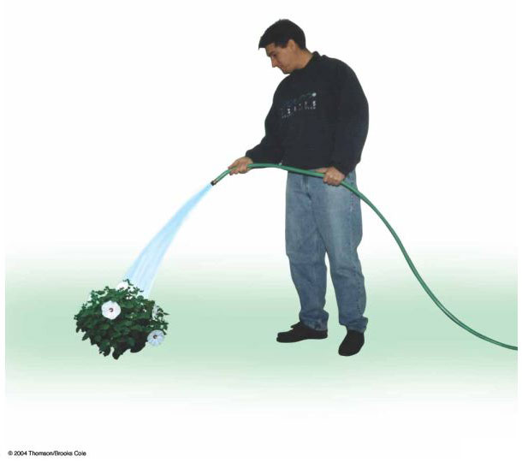

Figure P9.13

14. A glider of mass m is free to slide along a horizontal air track. It is pushed against a launcher at one end of the track. Model the launcher as a light spring of force constant k, compressed by a distance x. The glider is released from rest. (a) Show that the glider attains a speed
v = x (k/m)^{1/2}. (b) Does a glider of large or of small mass attain a greater speed? (c) Show that the impulse imparted to the glider is given by the expression x(k m)^{1/2}. (d) Is a greater impulse injected into a large or a small mass? (e) Is more work done on a large or a small mass?

Section 9.3 Collisions in One Dimension

15. High-speed stroboscopic photographs show that the head of a golf club of mass 200 g is traveling at 55.0 m/s just before it strikes a 46.0-g golf ball at rest on a tee. After the collision, the club head travels (in the same direction) at 40.0 m/s. Find the speed of the golf ball just after impact.

16. An archer shoots an arrow towards a target that is sliding towards her with a speed of 2.50 m/s on a smooth, slippery surface. The 22.5-g arrow is shot with a speed of 35.0 m/s and passes through the 300-g target, which is stopped by the impact. What is the speed of the arrow after passing through the target?

17. A 10.0-g bullet is fired into a stationary block of wood (m = 5.00 kg). The relative motion of the bullet stops inside the block. The speed of the bullet-plus-wood combination immediately after the collision is 0.600 m/s. What was the original speed of the bullet?

18. A railroad car of mass 2.50 × 10⁴ kg is moving with a speed of 4.00 m/s. It collides and couples with three other coupled railroad cars, each of the same mass as the single car and moving in the same direction with an initial speed of 2.00 m/s. (a) What is the speed of the four cars after the collision? (b) How much mechanical energy is lost in the collision?

19. Four railroad cars, each of mass
2.50 10⁴ kg, are coupled together and coasting along horizontal tracks at speed v_{i} toward the south. A very strong but foolish movie actor, riding on the second car, uncouples the front car and gives it a big push, increasing its speed to 4.00 m/s southward. The remaining three cars continue moving south, now at 2.00 m/s. (a) Find the initial speed of the cars. (b) How much work did the actor do? (c) State the relationship between the process described here and the process in Problem 18.

20. Two blocks are free to slide along the frictionless wooden track ABC shown in Figure P9.20. A block of mass m₁ = 5.00 kg is released from A. Protruding from its front end is the north pole of a strong magnet, repelling the north pole of an identical magnet embedded in the back end of the block of mass m₂ = 10.0 kg, initially at rest. The two blocks never touch. Calculate the maximum height to which m₁ rises after the elastic collision.

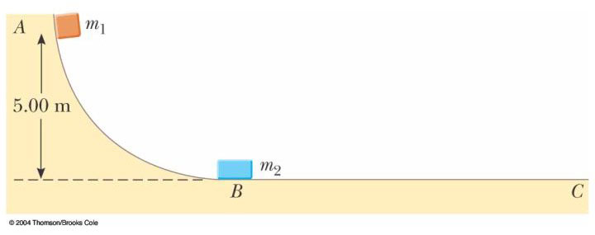

Figure P9.20

21. A 45.0-kg girl is standing on a plank that has a mass of 150 kg. The plank, originally at rest, is free to slide on a frozen lake, which is a flat, frictionless supporting surface. The girl begins to walk along the plank at a constant speed of 1.50 m/s relative to the plank. (a) What is her speed relative to the ice surface? (b) What is the speed of the plank relative to the ice surface?

22. Most of us know intuitively that in a head-on collision between a large dump truck and a subcompact car, you are better off being in the truck than in the car. Why is this? Many people imagine that the collision force exerted on the car is much greater than that experienced by the truck. To substantiate this view, they point out that the car is crushed, whereas the truck is only dented. This idea of unequal forces, of course, is false. Newton’s third law tells us that both objects experience forces of the same magnitude. The truck suffers less damage because it is made of stronger metal. But what about the two drivers? Do they experience the same forces? To answer this question, suppose that each vehicle is initially moving at 8.00 m/s and that they undergo a perfectly inelastic head-on collision. Each driver has mass 80.0 kg. Including the drivers, the total vehicle masses are 800 kg for the car and 4 000 kg for the truck. If the collision time is 0.120 s, what force does the seatbelt exert on each driver?

23. A neutron in a nuclear reactor makes an elastic head-on collision with the nucleus of a carbon atom initially at rest. (a) What fraction of the neutron's kinetic energy is transferred to the carbon nucleus? (b) If the initial kinetic energy of the neutron is 1.60 × 10^{–13} J, find its final kinetic energy and the kinetic energy of the carbon nucleus after the collision. (The mass of the carbon nucleus is nearly 12.0 times the mass of the neutron.)

24. As shown in Figure P9.24, a bullet of mass m and speed v passes completely through a pendulum bob of mass M. The bullet emerges with a speed of v/2. The pendulum bob is suspended by a stiff rod of length and negligible mass. What is the minimum value of v such that the pendulum bob will barely swing through a complete vertical circle?

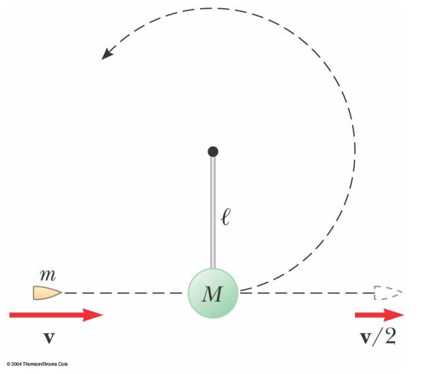

Figure P9.24

25. A 12.0-g wad of sticky clay is hurled horizontally at a 100-g wooden block initially at rest on a horizontal surface. The clay sticks to the block. After impact, the block slides 7.50 m before coming to rest. If the coefficient of friction between the block and the surface is 0.650, what was the speed of the clay immediately before impact?

26. A 7.00-g bullet, when fired from a gun into a 1.00-kg block of wood held in a vise, penetrates the block to a depth of
8.00 cm. What If? This block of wood is placed on a frictionless horizontal surface, and a second 7.00-g bullet is fired from the gun into the block. To what depth will the bullet penetrate the block in this case?

27. (a) Three carts of masses 4.00 kg,
10.0 kg, and 3.00 kg move on a frictionless horizontal track with speeds of 5.00 m/s, 3.00 m/s, and 4.00 m/s, as shown in Figure P9.27. Velcro couplers make the carts stick together after colliding. Find the final velocity of the train of three carts. (b) What If? Does your answer require that all the carts collide and stick together at the same time? What if they collide in a different order?

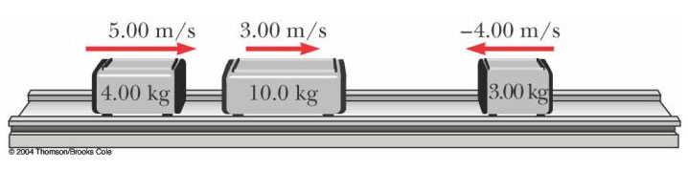

Figure P9.27

Section 9.4 Two-Dimensional Collisions

28. A 90.0-kg fullback running east with a speed of 5.00 m/s is tackled by a 95.0-kg opponent running north with a speed of 3.00 m/s. If the collision is perfectly inelastic, (a) calculate the speed and direction of the players just after the tackle and (b) determine the mechanical energy lost as a result of the collision. Account for the missing energy.

29. Two shuffleboard disks of equal mass, one orange and the other yellow, are involved in an elastic, glancing collision. The yellow disk is initially at rest and is struck by the orange disk moving with a speed of 5.00 m/s. After the collision, the orange disk moves along a direction that makes an angle of 37.0° with its initial direction of motion. The velocities of the two disks are perpendicular after the collision. Determine the final speed of each disk.

30. Two shuffleboard disks of equal mass, one orange and the other yellow, are involved in an elastic, glancing collision. The yellow disk is initially at rest and is struck by the orange disk moving with a speed v_{i}. After the collision, the orange disk moves along a direction that makes an angle with its initial direction of motion. The velocities of the two disks are perpendicular after the collision. Determine the final speed of each disk.

31. The mass of the blue puck in Figure P9.31 is 20.0% greater than the mass of the green one. Before colliding, the pucks approach each other with momenta of equal magnitude and opposite directions, and the green puck has an initial speed of 10.0 m/s. Find the speeds of the pucks after the collision if half the kinetic energy is lost during the collision.

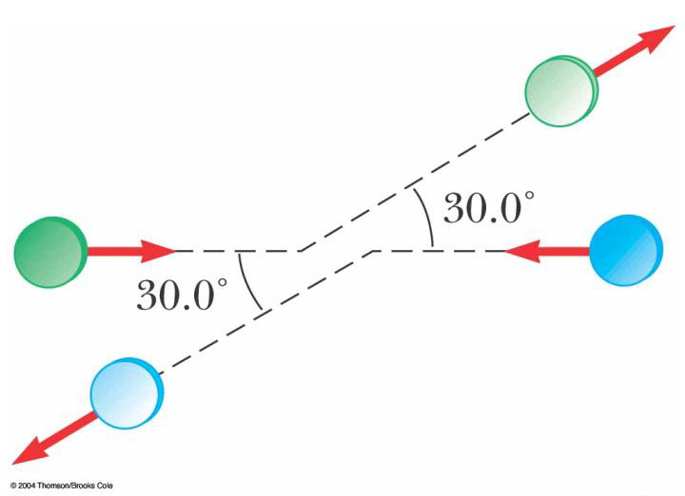

Figure P9.31

32. Two automobiles of equal mass approach an intersection. One vehicle is traveling with velocity 13.0 m/s toward the east and the other is traveling north with speed v_{2i}. Neither driver sees the other. The vehicles collide in the intersection and stick together, leaving parallel skid marks at an angle of 55.0º north of east. The speed limit for both roads is 35 mi/h and the driver of the northward-moving vehicle claims he was within the speed limit when the collision occurred. Is he telling the truth?

33. A billiard ball moving at 5.00 m/s strikes a stationary ball of the same mass. After the collision, the first ball moves at 4.33 m/s, at an angle of 30.0° with respect to the original line of motion. Assuming an elastic collision (and ignoring friction and rotational motion), find the struck ball's velocity after the collision.

34. A proton, moving with a velocity of , collides elastically with another proton that is initially at rest. If the two protons have equal speeds after the collision, find (a) the speed of each proton after the collision in terms of v_{i} and (b) the direction of the velocity vectors after the collision.

35. An object of mass 3.00 kg, with an initial velocity of , collides with and sticks to an object of mass 2.00 kg, with an initial velocity of . Find the final velocity of the composite object.

36. Two particles with masses m and 3m are moving toward each other along the x axis with the same initial speeds v_{i}. Particle m is traveling to the left, while particle 3m is traveling to the right. They undergo an elastic glancing collision such that particle m is moving downward after the collision at right angles from its initial direction. (a) Find the final speeds of the two particles. (b) What is the angle at which the particle 3m is scattered?

37. An unstable atomic nucleus of mass 17.0 × 10^{–27} kg initially at rest disintegrates into three particles. One of the particles, of mass 5.00 × 10^{–27} kg, moves along the y axis with a speed of 6.00 × 10⁶ m/s. Another particle, of mass 8.40 × 10^{–27} kg, moves along the x axis with a speed of 4.00 × 10⁶ m/s. Find (a) the velocity of the third particle and (b) the total kinetic energy increase in the process.

Section 9.5 The Center of Mass

38. Four objects are situated along the y axis as follows: a 2.00-kg object is at
+3.00 m, a 3.00-kg object is at +2.50 m, a 2.50-kg object is at the origin, and a 4.00-kg object is at –0.500 m. Where is the center of mass of these objects?

39. A water molecule consists of an oxygen atom with two hydrogen atoms bound to it (Fig. P9.39). The angle between the two bonds is 106°. If the bonds are 0.100 nm long, where is the center of mass of the molecule?

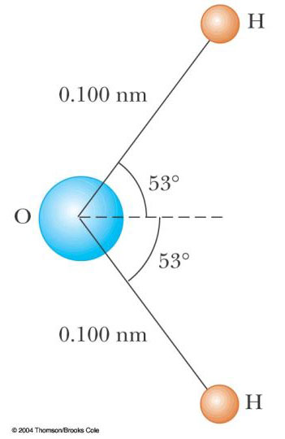

Figure P9.39

40. The mass of the Earth is
5.98 × 10²⁴ kg, and the mass of the Moon is 7.36 × 10²² kg. The distance of separation, measured between their centers, is
3.84 × 10⁸ m. Locate the center of mass of the Earth-Moon system as measured from the center of the Earth.

41. A uniform piece of sheet steel is shaped as in Figure P9.41. Compute the x and y coordinates of the center of mass of the piece.

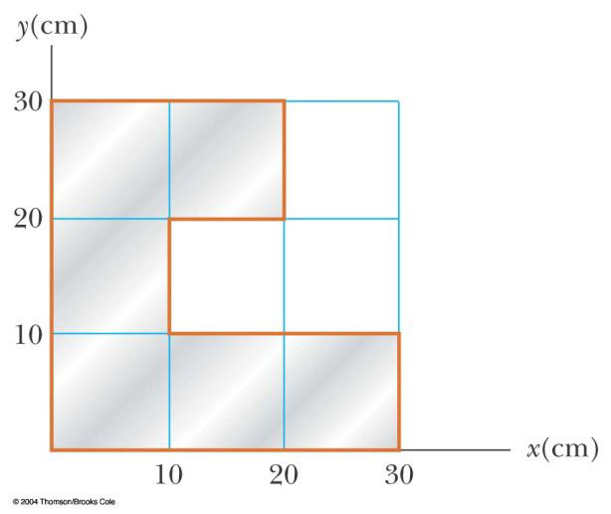

Figure P9.41

42. (a) Consider an extended object whose different portions have different elevations. Assume the free fall acceleration is uniform over the object. Prove that the gravitational potential energy of the object-Earth system is given by U_{g} = Mgy_{CM} where M is the total mass of the object and y_{CM} is the elevation of its center of mass above the chosen reference level. (b) Calculate the gravitational potential energy associated with a ramp, constructed on level ground with stone with density 3 800 kg/m³ and everywhere 3.60 m wide. In a side view, the ramp appears as a right triangle with height
15.7 m at the top end and base 64.8 m.

43. A rod of length 30.0 cm has linear density (mass-per-length) given by

= 50.0 g/m + 20.0 x g/m²,

where x is the distance from one end, measured in meters. (a) What is the mass of the rod? (b) How far from the x = 0 end is its center of mass?

44. In the 1968 Olympic Games, University of Oregon jumper Dick Fosbury introduced a new technique of high jumping called the “Fosbury flop”. It contributed to raising the world record by about 30 cm, and is presently used by nearly every world class jumper. In this technique, the jumper goes over the bar face up while arching his back as much as possible. This action places his center of mass outside his body, below his back. As his body goes over the bar, his center of mass passes below the bar. Because a given energy input implies a certain elevation for his center of mass, the action of arching his back means his body is higher than if his back were straight. As a model, consider the jumper as a thin uniform rod of length L. When the rod is straight, its center of mass is at its center. Now bend the rod in a circular arc so that it subtends an angle of 90.0º at the center of the arc, as shown in Figure P9.44b. In this configuration, how far outside the rod is the center of mass?

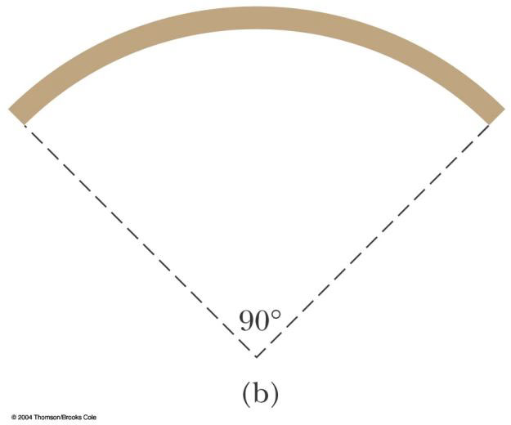

Figure P9.44

Section 9.6 Motion of a System of Particles

45. A 2.00-kg particle has a velocity , and a 3.00-kg particle has a velocity . Find (a) the velocity of the center of mass and (b) the total momentum of the system.

46. Consider a system of two particles in the xy plane: m₁ = 2.00 kg is at the location and has a velocity of ; m₂ = 3.00 kg is at and has velocity . (a) Plot these particles on a grid or graph paper. Draw their position vectors and show their velocities. (b) Find the position of the center of mass of the system and mark it on the grid. (c) Determine the velocity of the center of mass and also show it on the diagram. (d) What is the total linear momentum of the system?

47. Romeo (77.0 kg) entertains Juliet (55.0 kg) by playing his guitar from the rear of their boat at rest in still water, 2.70 m away from Juliet who is in the front of the boat. After the serenade, Juliet carefully moves to the rear of the boat (away from shore) to plant a kiss on Romeo's cheek. How far does the 80.0-kg boat move toward the shore it is facing?

48. A ball of mass 0.200 kg has a velocity of ; a ball of mass 0.300 kg has a velocity of . They meet in a head-on elastic collision. (a) Find their velocities after the collision. (b) Find the velocity of their center of mass before and after the collision.

Section 9.7 Rocket Propulsion

49. The first stage of a Saturn V space vehicle consumed fuel and oxidizer at the rate of 1.50 × 10⁴ kg/s, with an exhaust speed of 2.60 × 10³ m/s. (a) Calculate the thrust produced by these engines. (b) Find the acceleration of the vehicle just as it lifted off the launch pad on the Earth if the vehicle’s initial mass was 3.00 × 10⁶ kg. Note: You must include the gravitational force to solve part (b).

50. Model rocket engines are sized by thrust, thrust duration, and total impulse, among other characteristics. A size C5 model rocket engine has an average thrust of 5.26 N, a fuel mass of 12.7 grams, and an initial mass of 25.5 grams. The duration of its burn is 1.90 s. (a) What is the average exhaust speed of the engine? (b) If this engine is placed in a rocket body of mass 53.5 grams, what is the final velocity of the rocket if it is fired in outer space? Assume the fuel burns at a constant rate.

51. A rocket for use in deep space is to be capable of boosting a total load (payload plus rocket frame and engine) of 3.00 metric tons to a speed of 10 000 m/s. (a) It has an engine and fuel designed to produce an exhaust speed of 2 000 m/s. How much fuel plus oxidizer is required? (b) If a different fuel and engine design could give an exhaust speed of 5 000 m/s, what amount of fuel and oxidizer would be required for the same task?

52. Rocket Science. A rocket has total mass M_{i} = 360 kg, including 330 kg of fuel and oxidizer. In interstellar space it starts from rest, turns on its engine at time t = 0, and puts out exhaust with relative speed
v_{e} = 1 500 m/s at the constant rate
k = 2.50 kg/s. The fuel will last for an actual burn time of 330 kg/(2.5 kg/s) = 132 s, but define a “projected depletion time” as
T_{p} = M_{i}/k = 144 s. (This would be the burn time if the rocket could use its payload and fuel tanks as fuel, and even the walls of the combustion chamber.) (a) Show that during the burn the velocity of the rocket is given as a function of time by

v(t) = −v_{e} ln [1 − (t/T_{p})]

(b) Make a graph of the velocity of the rocket as a function of time for times running from 0 to 132 s. (c) Show that the acceleration of the rocket is

a(t) = v_{e}/(T_{p} − t)

(d) Graph the acceleration as a function of time. (e) Show that the displacement of the rocket is

x(t) = v_{e}(T_{p} − t) ln [1 − (t/T_{p})] + v_{e}t

(f) Graph the displacement during the burn.

53. An orbiting spacecraft is described not as a “zero-g,” but rather as a “microgravity” environment for its occupants and for on-board experiments. Astronauts experience slight lurches due to the motions of equipment and other astronauts, and due to venting of materials from the craft. Assume that a 3 500-kg spacecraft undergoes an acceleration of
2.50 g = 2.45 × 10^{–5} m/s² due to a leak from one of its hydraulic control systems. The fluid is known to escape with a speed of 70.0 m/s into the vacuum of space. How much fluid will be lost in one hour if the leak is not stopped?
Additional Problems

54. Two gliders are set in motion on an air track. A spring of force constant k is attached to the near side of one glider. The first glider of mass m₁ has velocity v₁ and the second glider of mass m₂ moves more slowly, with velocity v₂, as in Figure P9.54. When m₁ collides with the spring attached to m₂ and compresses the spring to its maximum compression x_{max}, the velocity of the gliders is v. In terms of v₁, v₂, m₁, m₂, and k, find (a) the velocity v at maximum compression, (b) the maximum compression x_{max}, and (c) the velocity of each glider after m₁ has lost contact with the spring.

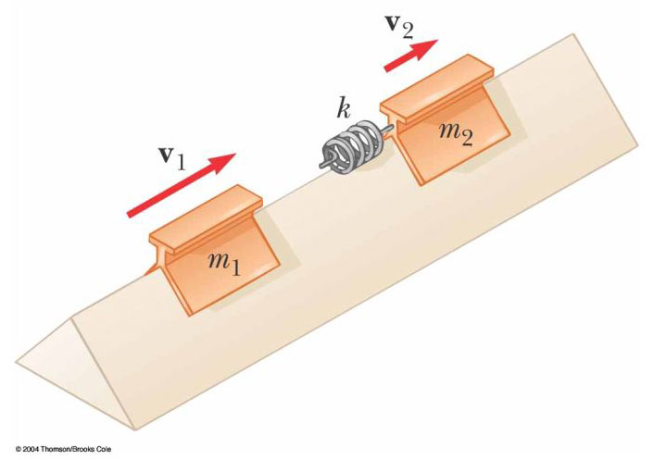

Figure P9.54

55. Review problem. A 60.0-kg person running at an initial speed of 4.00 m/s jumps onto a 120-kg cart initially at rest (Figure P9.55). The person slides on the cart’s top surface and finally comes to rest relative to the cart. The coefficient of kinetic friction between the person and the cart is 0.400. Friction between the cart and ground can be neglected. (a) Find the final velocity of the person and cart relative to the ground. (b) Find the friction force acting on the person while he is sliding across the top surface of the cart. (c) How long does the friction force act on the person? (d) Find the change in momentum of the person and the change in momentum of the cart. (e) Determine the displacement of the person relative to the ground while he is sliding on the cart. (f) Determine the displacement of the cart relative to the ground while the person is sliding. (g) Find the change in kinetic energy of the person. (h) Find the change in kinetic energy of the cart. (i) Explain why the answers to (g) and (h) differ. (What kind of collision is this, and what accounts for the loss of mechanical energy?)

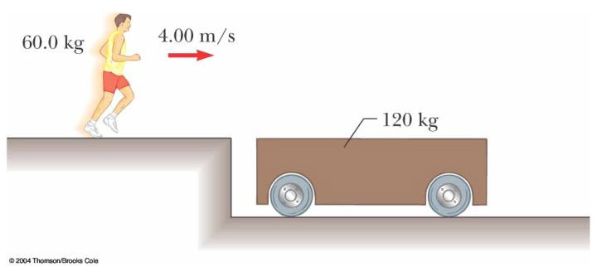

Figure P9.55

56. A golf ball (m = 46.0 g) is struck with a force that makes an angle of 45.0° with the horizontal. The ball lands 200 m away on a flat fairway. If the golf club and ball are in contact for 7.00 ms, what is the average force of impact? (Neglect air resistance.)

57. An 80.0-kg astronaut is working on the engines of his ship, which is drifting through space with a constant velocity. The astronaut, wishing to get a better view of the Universe, pushes against the ship and much later finds himself 30.0 m behind the ship. Without a thruster, the only way to return to the ship is to throw his 0.500-kg wrench directly away from the ship. If he throws the wrench with a speed of 20.0 m/s relative to the ship, how long does it take the astronaut to reach the ship?

58. A bullet of mass m is fired into a block of mass M initially at rest at the edge of a frictionless table of height h (Fig. P9.58). The bullet remains in the block, and after impact the block lands a distance d from the bottom of the table. Determine the initial speed of the bullet.

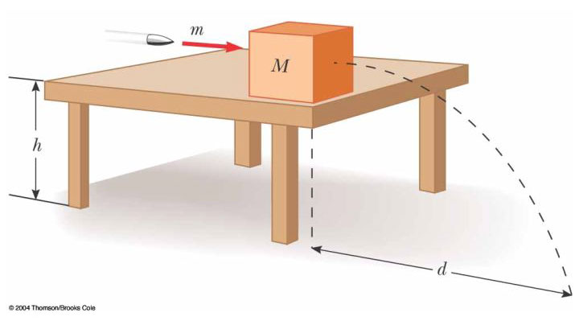

Figure P9.58

59. A 0.500-kg sphere moving with a velocity strikes another sphere of mass 1.50 kg moving with a velocity . (a) If the velocity of the 0.500-kg sphere after the collision is , find the final velocity of the 1.50-kg sphere and identify the kind of collision (elastic, inelastic, or perfectly inelastic). (b) If the velocity of the 0.500-kg sphere after the collision is , find the final velocity of the 1.50-kg sphere and identify the kind of collision. (c) What If? If the velocity of the 0.500-kg sphere after the collision is , find the value of a and the velocity of the 1.50-kg sphere after an elastic collision.

60. A small block of mass m₁ = 0.500 kg is released from rest at the top of a curve-shaped frictionless wedge of mass m₂ = 3.00 kg, which sits on a frictionless horizontal surface as in Figure P9.60a. When the block leaves the wedge, its velocity is measured to be 4.00 m/s to the right, as in FigureP9.60b. (a) What is the velocity of the wedge after the block reaches the horizontal surface? (b) What is the height h of the wedge?

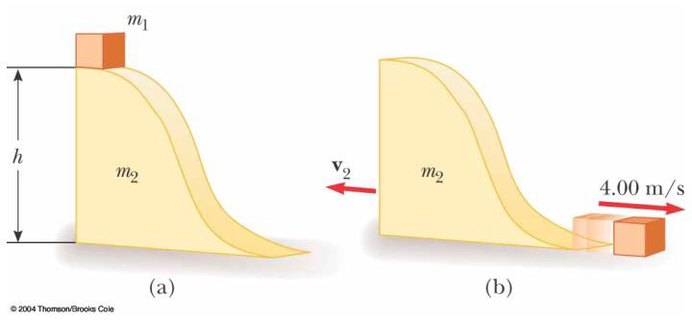

Figure P9.60

61. A bucket of mass m and volume V is attached to a light cart, completely covering its top surface. The cart is given a quick push along a straight, horizontal, smooth road. It is raining, so that as the cart cruises along without friction, the bucket gradually fills with water. By the time the bucket is full, its speed is v. (a) What was the initial speed v_{i} of the cart? Let represent the density of water. (b) What If? Assume that when the bucket is half full, it develops a slow leak at the bottom, so that the level of the water remains constant thereafter. Describe qualitatively what happens to the speed of the cart after the leak develops.

62. A 75.0-kg firefighter slides down a pole while a constant friction force of 300 N retards her motion. A horizontal 20.0-kg platform is supported by a spring at the bottom of the pole to cushion the fall. The firefighter starts from rest 4.00 m above the platform, and the spring constant is
4 000 N/m. Find (a) the firefighter's speed just before she collides with the platform and (b) the maximum distance the spring is compressed. (Assume the friction force acts during the entire motion.)

63. George of the Jungle, with mass m, swings on a light vine hanging from a stationary tree branch. A second vine of equal length hangs from the same point, and a gorilla of larger mass M swings in the opposite direction on it. Both vines are horizontal when the primates start from rest at the same moment. George and the gorilla meet at the lowest point of their swings. Each is afraid that one vine will break, so they grab each other and hang on. They swing upward together, reaching a point where the vines make an angle of 35.0° with the vertical. (a) Find the value of the ratio m/M. (b) What If? Try this at home. Tie a small magnet and a steel screw to opposite ends of a string. Hold the center of the string fixed to represent the tree branch, and reproduce a model of the motions of George and the gorilla. What changes in your analysis will make it apply to this situation? What If? Assume the magnet is strong, so that it noticeably attracts the screw over a distance of a few centimeters. Then the screw will be moving faster just before it sticks to the magnet. Does this make a difference?

64. A cannon is rigidly attached to a carriage, which can move along horizontal rails but is connected to a post by a large spring, initially unstretched and with force constant k = 2.00 × 10⁴ N/m, as in Figure P9.64. The cannon fires a 200-kg projectile at a velocity of 125 m/s directed 45.0° above the horizontal. (a) If the mass of the cannon and its carriage is 5 000 kg, find the recoil speed of the cannon. (b) Determine the maximum extension of the spring. (c) Find the maximum force the spring exerts on the carriage. (d) Consider the system consisting of the cannon, carriage, and shell. Is the momentum of this system conserved during the firing? Why or why not?

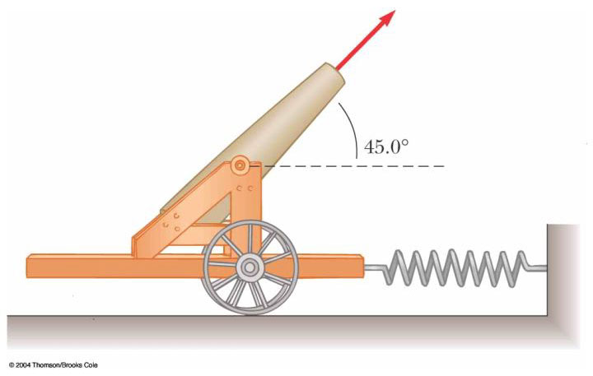

Figure P9.64
65. A student performs a ballistic pendulum experiment using an apparatus similar to that shown in Figure 9.11b. She obtains the following average data:
h = 8.68 cm, m₁ = 68.8 g, and m₂ = 263 g. The symbols refer to the quantities in Figure 9.11a. (a) Determine the initial speed v_{1A} of the projectile. (b) The second part of her experiment is to obtain v_{1A} by firing the same projectile horizontally (with the pendulum removed from the path), by measuring its horizontal position x and distance of fall y (Fig. P9.65). Show that the initial speed of the projectile is related to x and y through the relation

What numerical value does she obtain for v_{1A} based on her measured values of
x = 257 cm and y = 85.3 cm? What factors might account for the difference in this value compared to that obtained in part (a)?

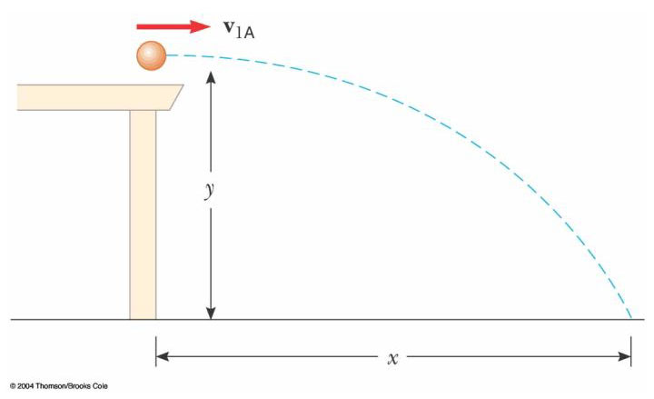

Figure P9.65

66. Small ice cubes, each of mass 5.00 g, slide down a frictionless track in a steady stream, as shown in Figure P9.66. Starting from rest, each cube moves down through a net vertical distance of 1.50 m, and leaves the bottom end of the track at an angle of 40.0° above the horizontal. At the highest point of its subsequent trajectory, the cube strikes a vertical wall and rebounds with half the speed it had upon impact. If 10.0 cubes strike the wall per second, what average force is exerted on the wall?

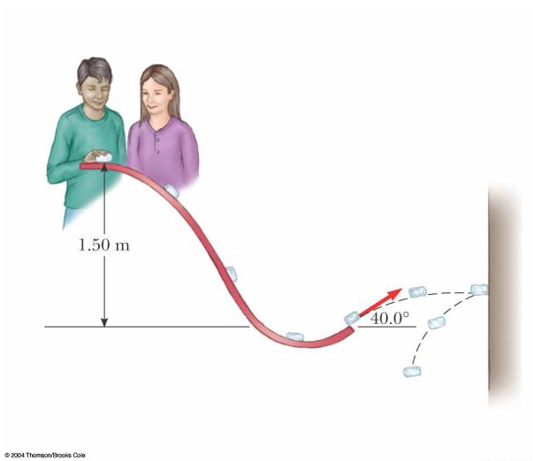

Figure P9.66

67. A 5.00-g bullet moving with an initial speed of 400 m/s is fired into and passes through a 1.00-kg block, as in Figure P9.67. The block, initially at rest on a frictionless, horizontal surface, is connected to a spring of force constant 900 N/m. If the block moves 5.00 cm to the right after impact, find (a) the speed at which the bullet emerges from the block and (b) the mechanical energy converted into internal energy in the collision.

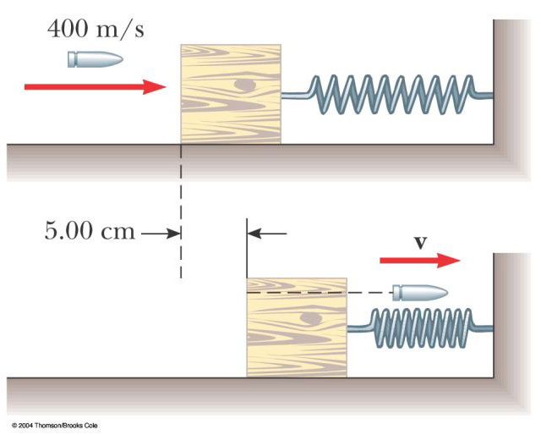

Figure P9.67

68. Consider as a system the Sun with the Earth in a circular orbit around it. Find the magnitude of the change in the velocity of the Sun relative to the center of mass of the system over the period of six months. Neglect the influence of other celestial objects. You may obtain the necessary astronomical data from the endpapers of the book.

69. Review problem. There are (one can say) three coequal theories of motion. They are: Newton’s second law, stating that the total force on an object causes its acceleration; the work–kinetic energy theorem, stating that the total work on an object causes its change in kinetic energy; and the impulse–momentum theorem, stating that the total impulse on an object causes its change in momentum. In this problem, you compare predictions of the three theories in one particular case. A 3.00-kg object has velocity . Then, a total force acts on the object for 5.00 s. (a) Calculate the object’s final velocity, using the impulse–momentum theorem. (b) Calculate its acceleration from a = (v_{f} – v_{i})/ t. (c) Calculate its acceleration from a = ΣF/m. (d) Find the object’s vector displacement from . (e) Find the work done on the object from W = F⋅r. (f) Find the final kinetic energy from . (g) Find the final kinetic energy from .

70. A rocket has total mass M_{i} = 360 kg, including 330 kg of fuel and oxidizer. In interstellar space it starts from rest. Its engine is turned on at time t = 0, and it puts out exhaust with relative speed v_{e} = 1 500 m/s at the constant rate 2.50 kg/s. The burn lasts until the fuel runs out, at time 330 kg/(2.5 kg/s) = 132 s. Set up and carry out a computer analysis of the motion according to Euler’s method. Find (a) the final velocity of the rocket and (b) the distance it travels during the burn.

71. A chain of length L and total mass M is released from rest with its lower end just touching the top of a table, as in Figure P9.71a. Find the force exerted by the table on the chain after the chain has fallen through a distance x, as in Figure P9.71b. (Assume each link comes to rest the instant it reaches the table.)

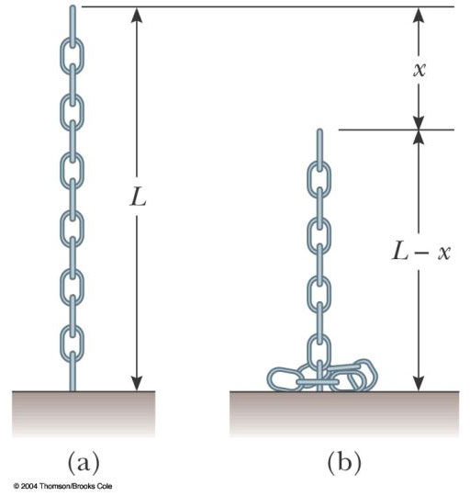

Figure P9.71

72. Sand from a stationary hopper falls onto a moving conveyor belt at the rate of 5.00 kg/s as in Figure P9.72. The conveyor belt is supported by frictionless rollers and moves at a constant speed of 0.750 m/s under the action of a constant horizontal external force F_{ext} supplied by the motor that drives the belt. Find (a) the sand's rate of change of momentum in the horizontal direction, (b) the force of friction exerted by the belt on the sand, (c) the external force F_{ext}, (d) the work done by F_{ext} in 1 s, and (e) the kinetic energy acquired by the falling sand each second due to the change in its horizontal motion. (f) Why are the answers to (d) and (e) different?

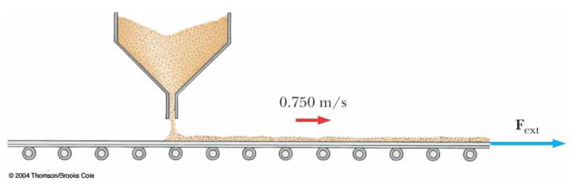

Figure P9.72

73. A golf club consists of a shaft connected to a club head. The golf club can be modeled as a uniform rod of length and mass m₁ extending radially from the surface of a sphere of radius R and mass m₂. Find the location of the club’s center of mass, measured from the center of the club head.

© Copyright 2004 Thomson. All rights reserved.

